**Wireshark Request and Response Message**

**Request:**

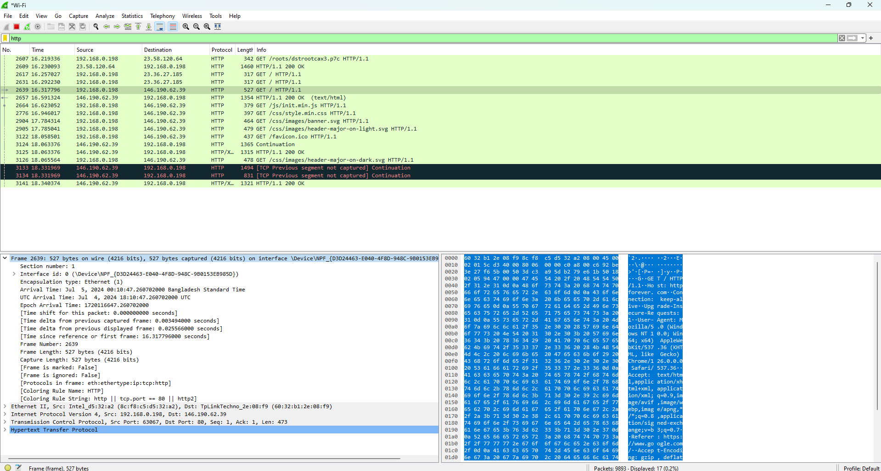

1. The 1st layer **Frame** contains detailed information about a specific frame (packet) captured on the network, like its arriving time, frame number, frame size

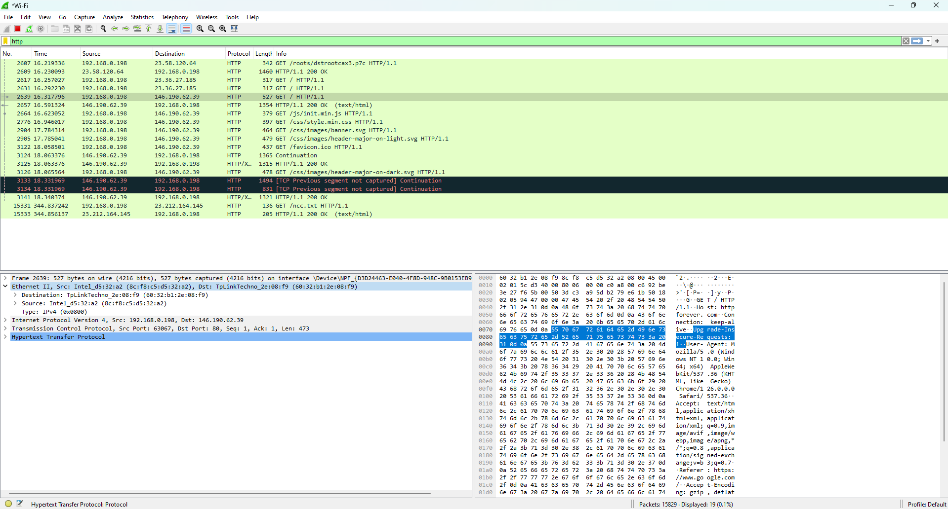

1. The 2nd layer contains an **Ethernet frame** from a packet capture focused on the Ethernet II header, Source MAC, Destination MAC, and the type of packet IPv4 or IPv6.

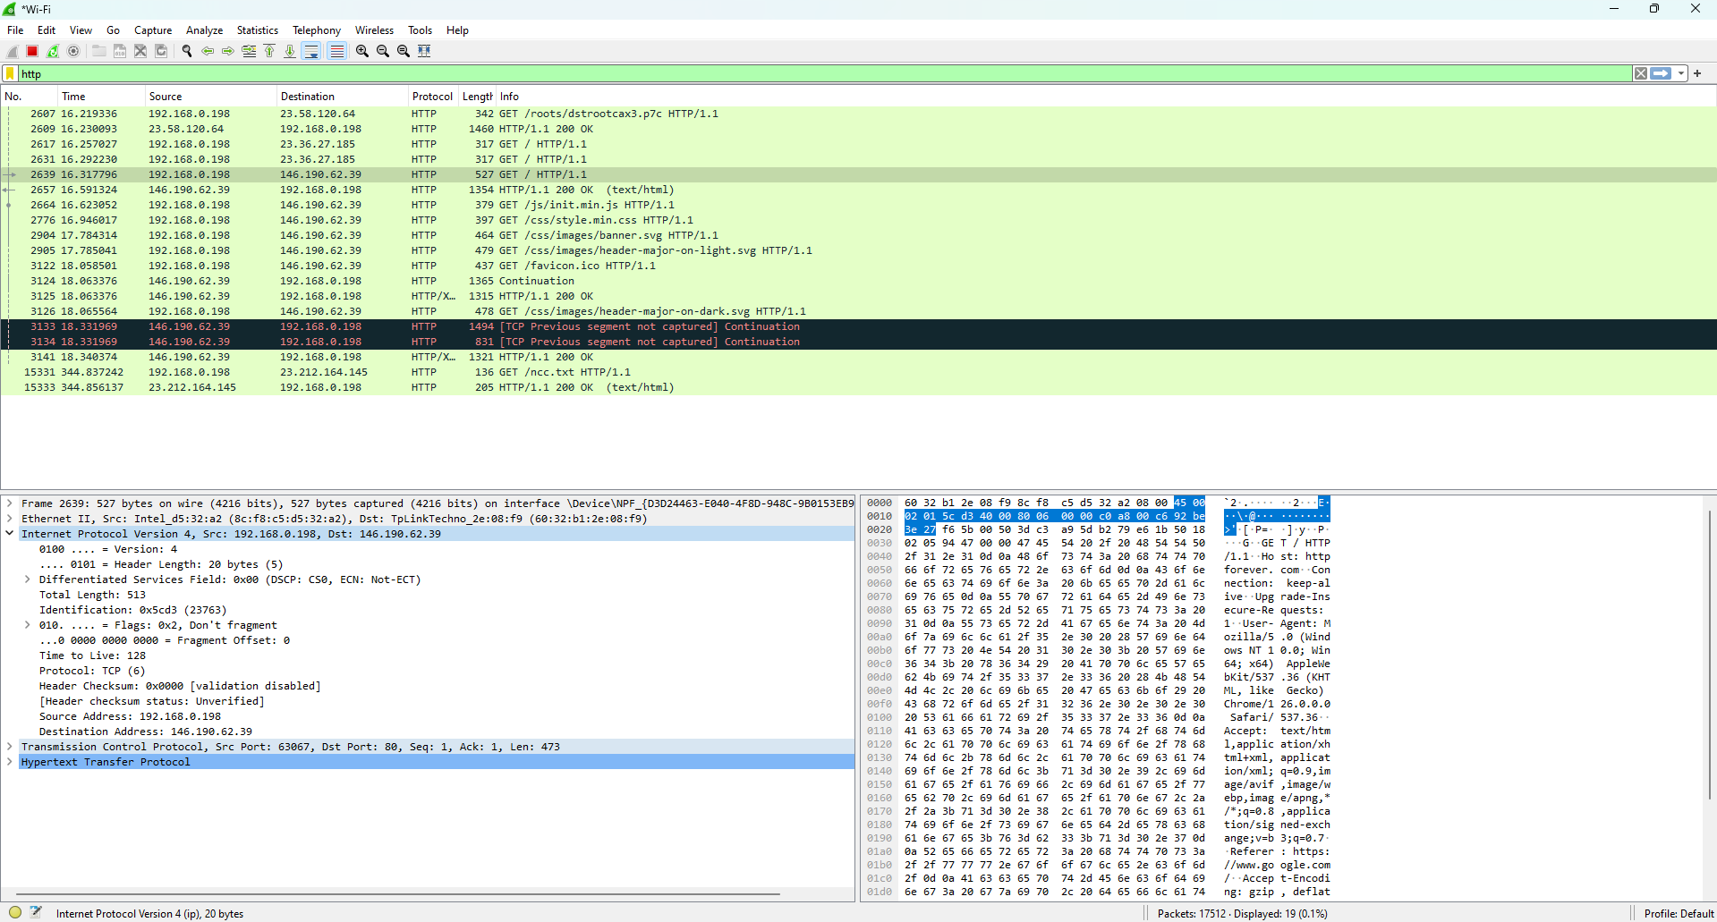

1. The 3rd layer is the **Internet Protocol Version**. It contains the information about source IP address and destination IP address which protocol it will use either TCP or UDP. It also does a header checksum operation to see if the information in the packet is still intact.

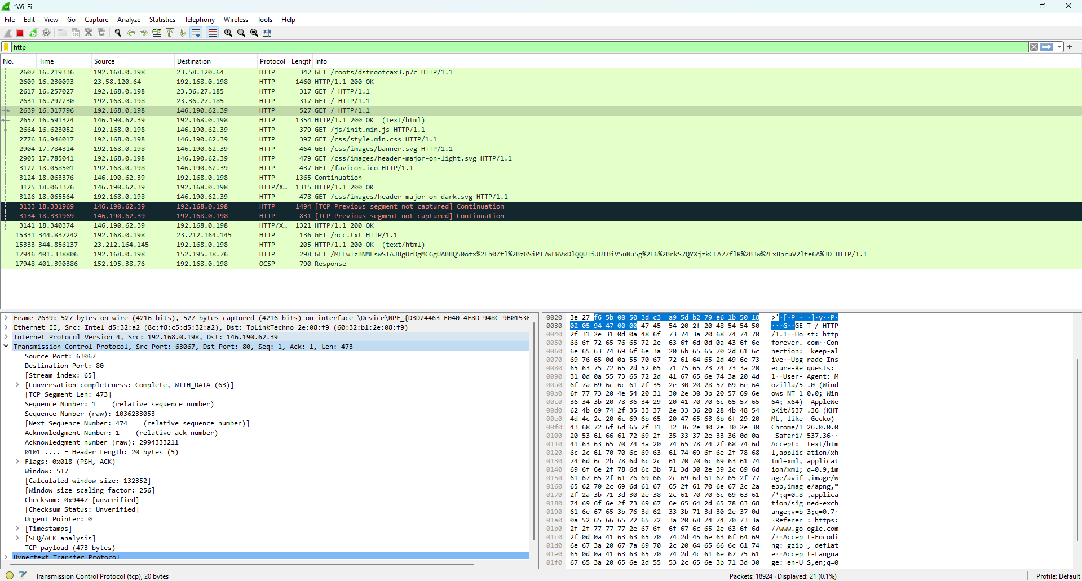

1. The 4th layer is the **Transmission Control Protocol (TCP) segment**. TCP is one of the fundamental protocols of the Internet and it is responsible for ensuring reliable communication between devices. It contains Source and destination ports, Sequence and acknowledgment numbers to ensure that all the data packets are received in the correct order. Checksum to ensure value is used to check for errors in the transmission of the data.

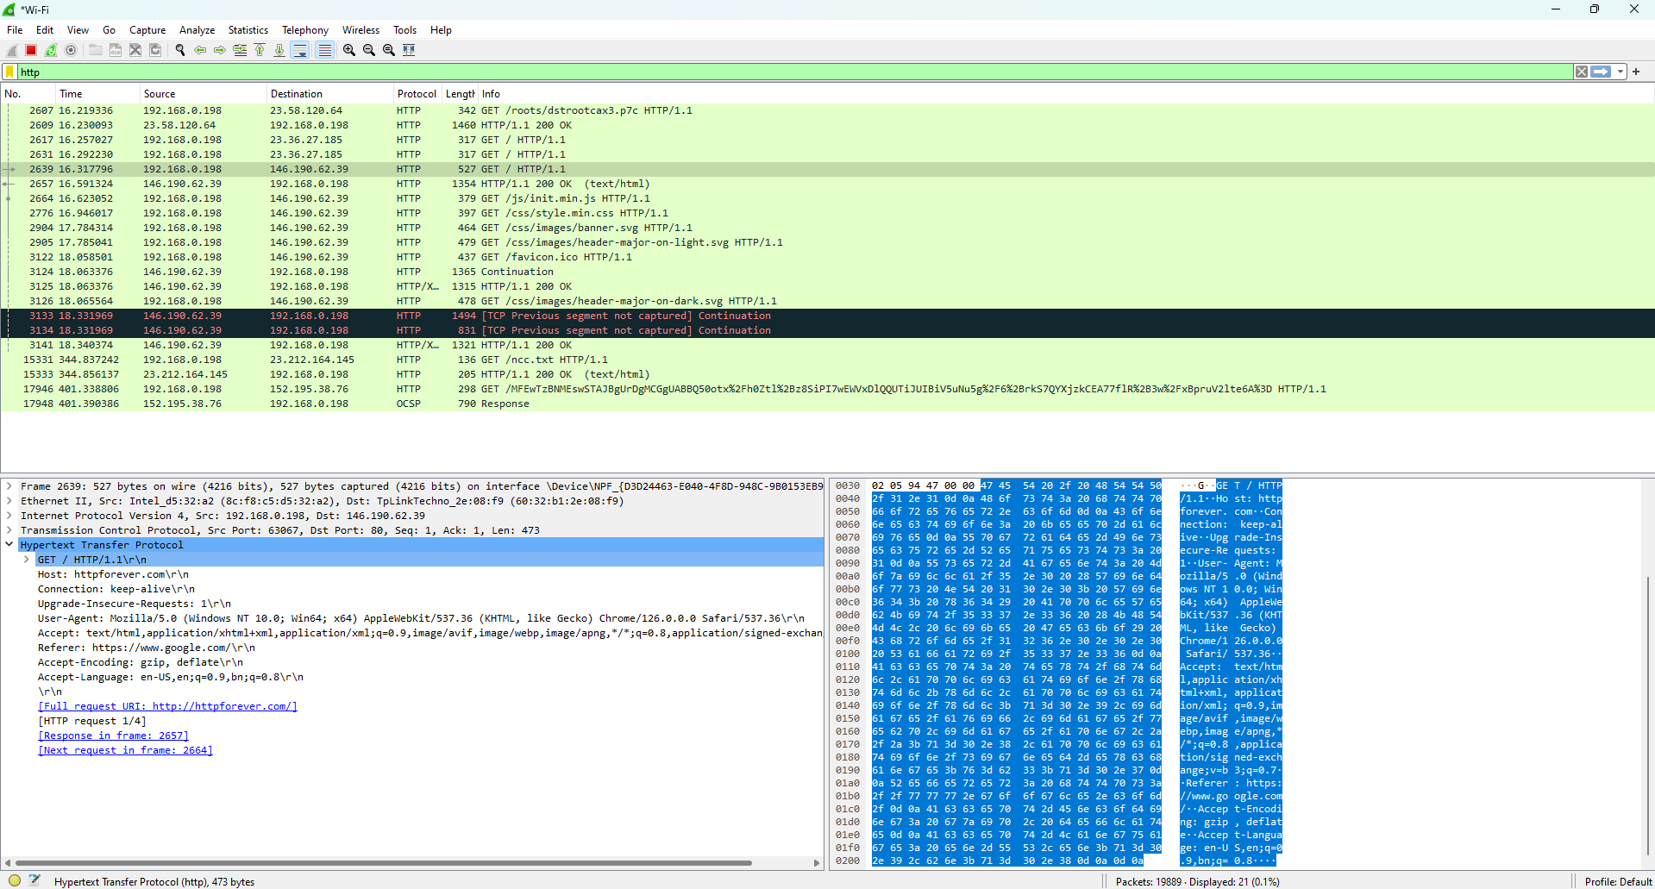

1. The 5th layer is the **HTTP request message** which contains various information like the version of HTTP, The connection status, Is the connection persistent or non-persistent, and host information (Information about which website the client wants to visit). User-agent(which web browser the client is using), Accepting language (which language is the server familiar with).

**Response:**

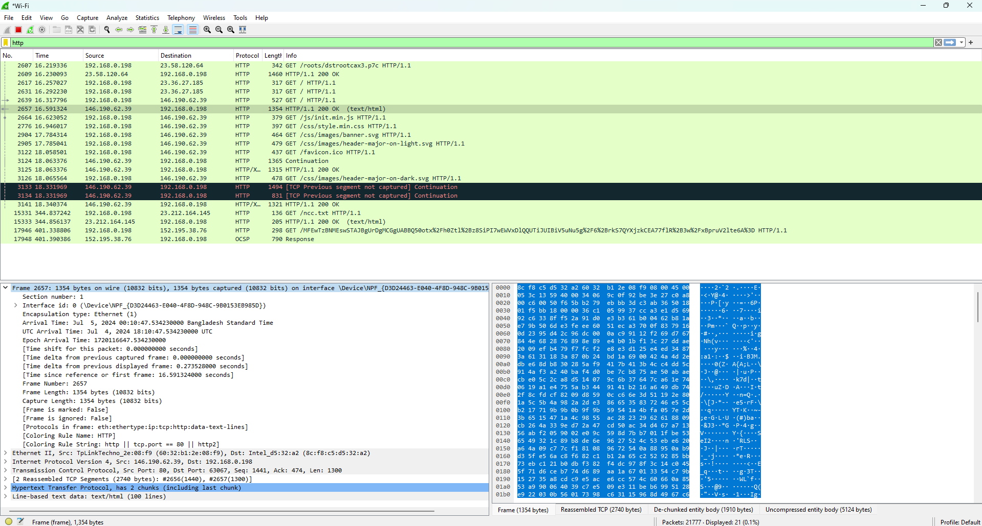

1. The 1st layer **Frame** contains detailed information about a specific frame (packet) captured on the network, like its arriving time, frame number, and frame size, encapsulation type.

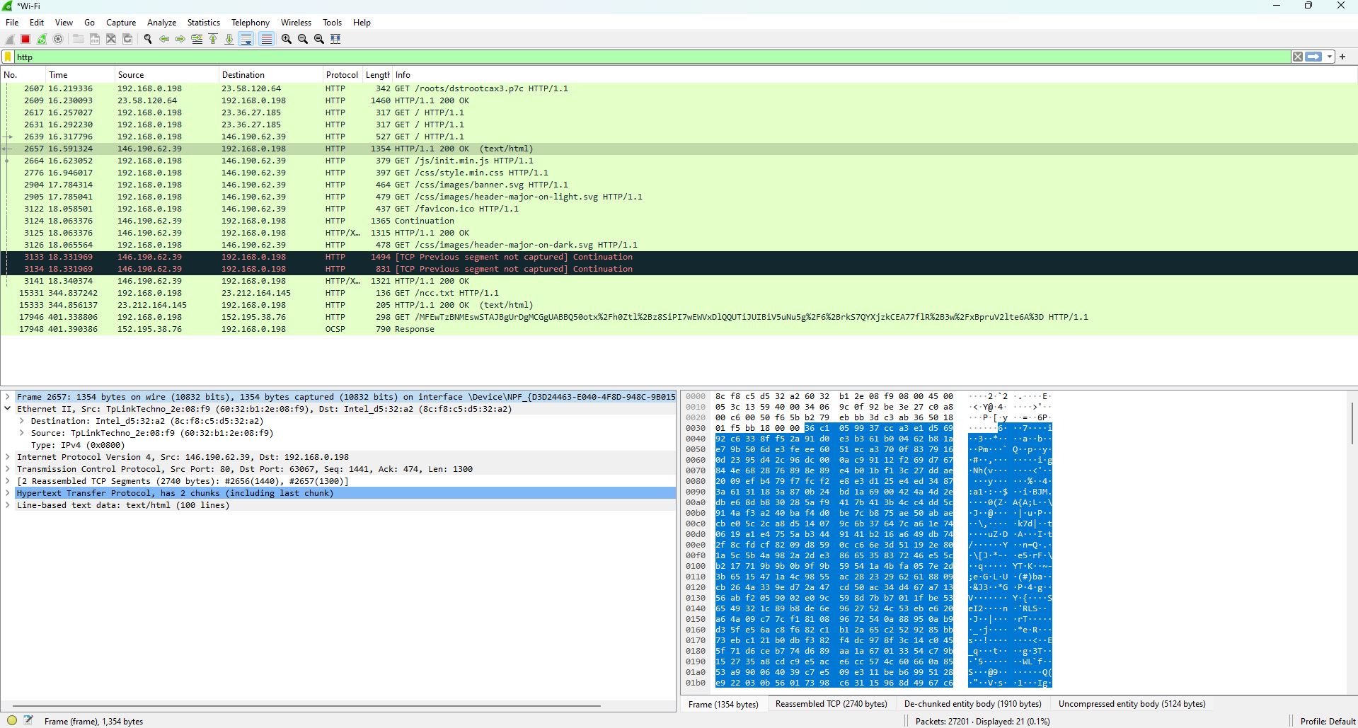

1. The 2nd layer contains an **Ethernet frame** from a packet capture focused on the Ethernet II header, Source MAC, Destination MAC, and the type of packet IPv4 or IPv6.

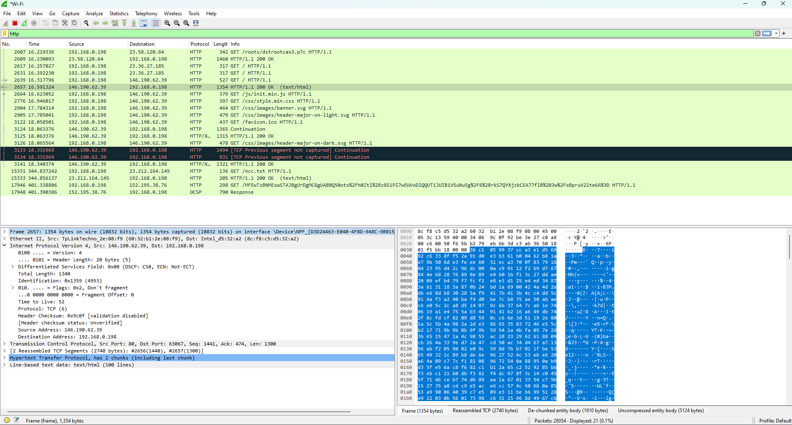

1. The 3rd layer is the **Internet Protocol Version**. It contains the information about source IP address and destination IP address which protocol it will use either TCP or UDP. Header length, Total length, It also does a header checksum operation to see if the information in the packet is still intact.

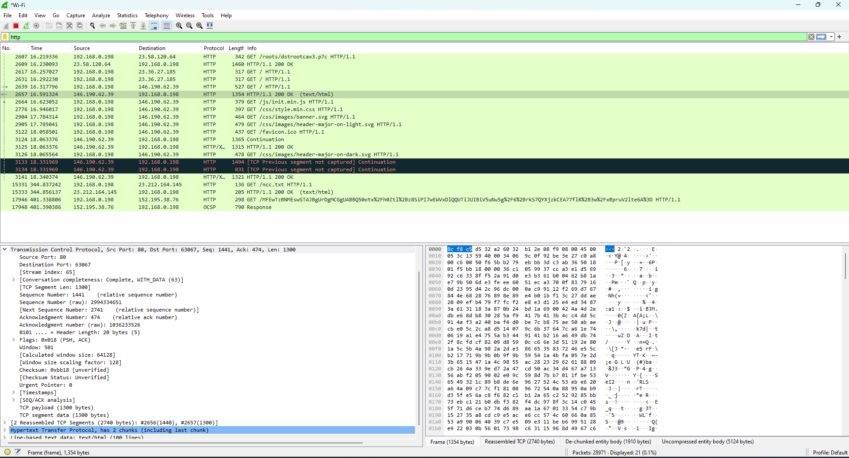

1. The 4th layer is the **Transmission Control Protocol (TCP) segment**. TCP is one of the fundamental protocols of the Internet and it is responsible for ensuring reliable communication between devices. It contains Source and destination ports, Sequence and acknowledgment numbers to ensure that all the data packets are received in the correct order. Checksum to ensure value is used to check for errors in the transmission of the data.

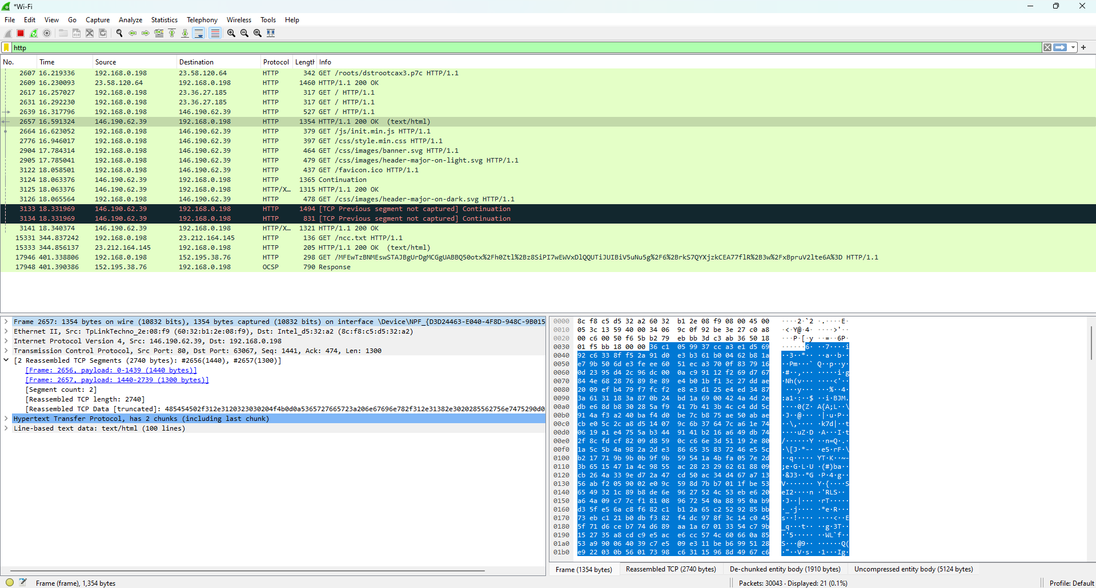

1. The 5th layer **reassembled the TCP segment**. It took two separate packets and reassembled them into a complete TCP segment based on their payload information. This process is necessary to analyze the flow of data within a TCP connection.

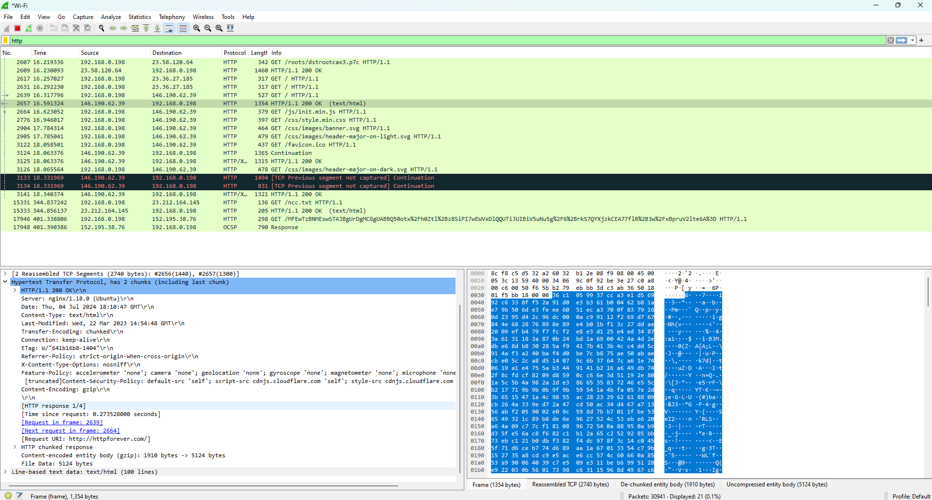

1. The 6th layer is the **HTTP response message** which contains information like the version of HTTP, request-response(OK means the request has been successfully accepted), The server information, Date, Content type, Modification status, The connection status, Is the connection persistent or non-persistent.

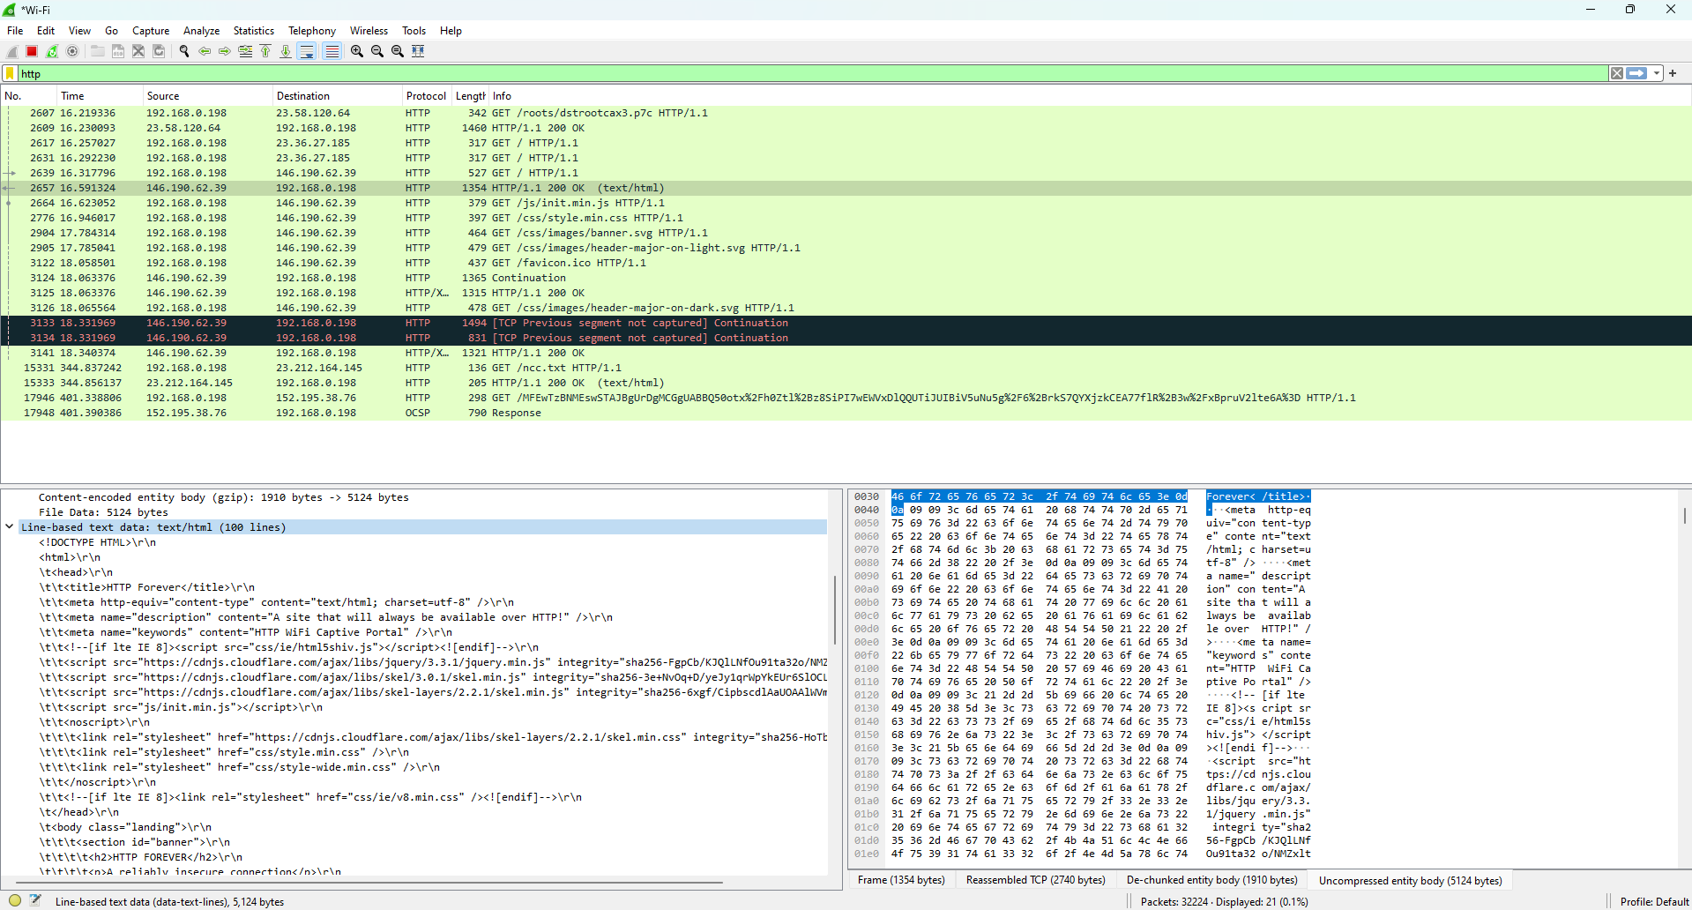

1. The 7th layer contains **Data,** From the Server to the Client.